Full Report for Brilliant

General Information

Model | Simple | Extra Facet Girdle / Nat | Yes (3)
Expert name | N/A | Extra Facet Crown | Yes (1)
Report date | 05.09.2011 | Extra Facet Pavilion | No
Real weight, ct |  | Appraiser title | N/A
Calculated weight, ct | 0.75, 0.7515 | Overall cut quality | N/A
Spread | -0.11 ct, -16.39% | Symmetry appraiser title | Symmetry
AGS Spread | N/A ct, N/A% | Overall symmetry quality | VG

Main Views
 | Front view |  |  | Left view
 | 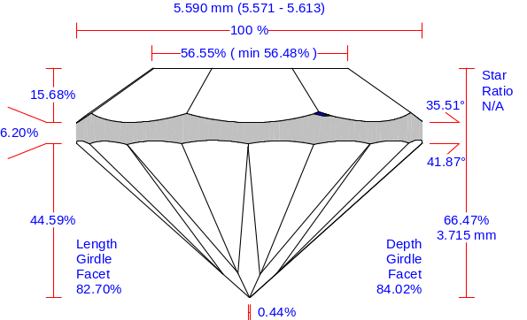 |  |  | 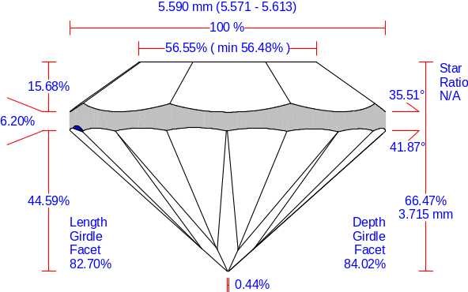
 | Rear view |  |  | Right view
 | 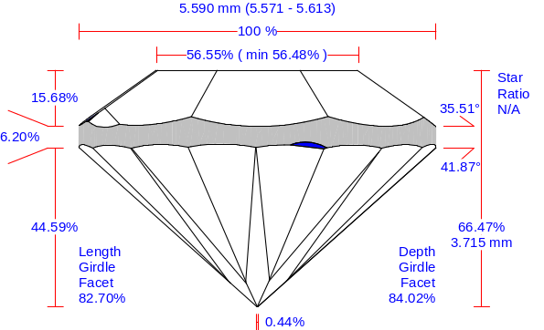 |  |  | 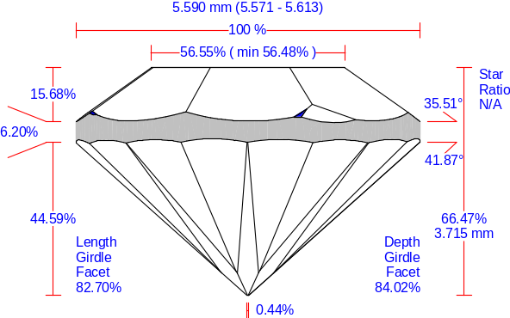

Main Parameters
Width | Length | Ratio (L/W) | Diameter Average | Diameter Minimum | Diameter Maximum | Total height | MIC | Girdle to MIC
5.571 mm | 5.613 mm | 1.007 | 5.590 mm | 5.571 mm | 5.613 mm | 3.715 mm | 5.568 mm | 0.002 mm

Parameter |  | Avg | Min | Max | Dev | Cut | Sym
Diameter | mm | 5.590 | 5.571 | 5.613 | 0.75 % | N/A | VG
Radius | mm | 2.794 | 2.784 | 2.808 | 0.024
Radius | % | 49.98 | 49.81 | 50.24 | 0.43
Crown angle | ° | 35.51 | 35.47 | 35.59 | 0.12 | N/A | EX
Crown height | % | 15.68 | 15.46 | 15.88 | 0.42 | N/A | EX
Crown height | mm | 0.876 | 0.864 | 0.887 | 0.023 | N/A | EX
Crown height bone | % | 13.00 | 12.70 | 13.20 | 0.50
Crown height bone | mm | 0.727 | 0.710 | 0.738 | 0.028
Crown height valley | % | 15.68 | 15.46 | 15.88 | 0.42 | N/A | EX
Crown height valley | mm | 0.876 | 0.864 | 0.887 | 0.024 | N/A | EX
Pavilion angle | ° | 41.87 | 41.79 | 41.92 | 0.13 | N/A | EX
Pavilion height | % | 44.59 | 44.35 | 44.78 | 0.43
Pavilion height | mm | 2.493 | 2.479 | 2.503 | 0.024
Pavilion height bezel | % | 44.59 | 44.35 | 44.78 | 0.43 | N/A | EX
Pavilion height bezel | mm | 2.493 | 2.479 | 2.503 | 0.024 | N/A | EX
Pavilion height upper bone | % | 44.62 | 44.37 | 44.86 | 0.50
Pavilion height upper bone | mm | 2.494 | 2.480 | 2.508 | 0.028
Pavilion height bone | % | 44.62 | 44.37 | 44.86 | 0.50
Pavilion height bone | mm | 2.494 | 2.480 | 2.508 | 0.028

Parameter |  | Avg | Min | Max | Dev | Cut | Sym
Pavilion height valley | % | 45.47 | 45.35 | 45.57 | 0.23 | N/A | EX
Pavilion height valley | mm | 2.542 | 2.535 | 2.547 | 0.013 | N/A | EX
Pavilion height valley type 2 | % | 45.49 | 45.29 | 45.72 | 0.43 | N/A | N/A
Pavilion height valley type 2 | mm | 2.543 | 2.531 | 2.556 | 0.024 | N/A | N/A
Upper girdle facets angle | ° | N/A | N/A | N/A | N/A |  | N/A
Upper girdle facets height | % | N/A | N/A | N/A | N/A |  | N/A
Upper girdle facets height | mm | N/A | N/A | N/A | N/A |  | N/A
Star facets angle | ° | N/A | N/A | N/A | N/A |  | N/A
Star :  Upper ratio | % | N/A :  N/A | N/A :  N/A | N/A :  N/A | N/A | N/A | N/A
Lower girdle facets angle | ° | 42.85 | 42.77 | 42.92 | 0.15 |  | EX
Lower girdle facets height | % | 38.50 | 37.87 | 39.31 | 1.44 | N/A | EX
Lower girdle facets height | mm | 2.152 | 2.117 | 2.197 | 0.081 | N/A | EX
Depth girdle facet | % | 84.02 | 82.63 | 85.37 | 2.73 | N/A | EX
Length girdle facet | % | 82.70 | 81.18 | 84.16 | 2.98 | N/A | EX
Total height | % | 66.47 |  |  |  | N/A
Total height | mm | 3.715 |  |  |  | N/A
Table | % | 56.55 | 56.48 | 56.61 | 0.13 | N/A | EX
Table | mm | 3.161 | 3.157 | 3.164 | 0.007 | N/A | EX
Culet | % | 0.44 | 0.36 | 0.52 | 0.16 | N/A | EX
Culet | mm | 0.025 | 0.020 | 0.029 | 0.009 | N/A | EX
Twist | ° | 1.45 | 1.05 | 1.72 | 0.68 |  | EX
Girdle height bezel | % | 6.20 | 5.90 | 6.47 | 0.57 | N/A | EX
Girdle height bezel | mm | 0.346 | 0.330 | 0.362 | 0.032 | N/A | EX
Girdle height bone | % | 8.85 | 8.48 | 9.26 | 0.77 |  | VG
Girdle height bone | mm | 0.494 | 0.474 | 0.517 | 0.043 |  | VG
Girdle height valley | % | 5.61 | 5.43 | 5.84 | 0.41 | N/A | EX
Girdle height valley | mm | 0.314 | 0.303 | 0.326 | 0.023 | N/A | EX
Girdle height valley type 2 | % | 5.71 | 5.43 | 6.14 | 0.71 | N/A | N/A
Girdle height valley type 2 | mm | 0.319 | 0.303 | 0.343 | 0.040 | N/A | N/A
Girdle height (Crown Mains) | % | 5.96 | 5.66 | 6.42 | 0.75
Girdle height (Crown Mains) | mm | 0.333 | 0.317 | 0.359 | 0.042
Girdle height (Pavilion Mains) | % | 6.21 | 5.91 | 6.48 | 0.57
Girdle height (Pavilion Mains) | mm | 0.347 | 0.330 | 0.362 | 0.032
Girdle height (Upper girdle facets) | % | N/A | N/A | N/A | N/A
Girdle height (Upper girdle facets) | mm | N/A | N/A | N/A | N/A
Girdle height (Lower girdle facets) | % | 5.98 | 5.52 | 6.82 | 1.30
Girdle height (Lower girdle facets) | mm | 0.334 | 0.308 | 0.381 | 0.073

Measurement as per OctoNus theory
Crown angle | ° | 35.51 | 35.48 | 35.55 | 0.06
Pavilion angle | ° | 41.87 | 41.85 | 41.88 | 0.03
Culet through bezel | ° | 3.97 |  |  |  | N/A
Fish eye effect | ° | 12.30 |  |  |  | N/A

Table of Correspondence of New Parameters and Obsolete Parameters (from Old Full Report for Brilliant)
Obsolete parameter | New parameter |  | Avg | Min | Max | Dev
Pavilion depth | Pavilion height bezel | % | 44.59 | 44.35 | 44.78 | 0.43
Pavilion depth | Pavilion height bezel | mm | 2.493 | 2.479 | 2.503 | 0.024

Table of Obsolete Parameters (from Old Full Report for Brilliant)
Obsolete parameter |  | Avg | Min | Max | Dev
Crown height at girdle minima | % | 15.68 | 15.46 | 15.88 | 0.42
Crown height at girdle minima | mm | 0.876 | 0.864 | 0.887 | 0.024
Pavilion depth bone | % | 44.62 | 44.37 | 44.86 | 0.50
Pavilion depth bone | mm | 2.494 | 2.480 | 2.508 | 0.028
Pavilion depth at girdle minima | % | 45.49 | 45.29 | 45.72 | 0.43
Pavilion depth at girdle minima | mm | 2.543 | 2.531 | 2.556 | 0.024

Detailed Parameters
Parameter |  | 1 | 2 | 3 | 4 | 5 | 6 | 7 | 8
Diameter | mm | 5.598 | 5.575 | 5.599 | 5.574
Radius | mm | 2.802 | 2.790 | 2.799 | 2.786 | 2.796 | 2.786 | 2.799 | 2.787
Radius | % | 50.12 | 49.91 | 50.07 | 49.84 | 50.01 | 49.83 | 50.08 | 49.85
Crown angle | ° | 35.50 | 35.52 | 35.59 | 35.49 | 35.47 | 35.52 | 35.50 | 35.49
Crown height | % | 15.55 | 15.49 | 15.79 | 15.72 | 15.88 | 15.74 | 15.79 | 15.46
Crown height | mm | 0.869 | 0.866 | 0.883 | 0.879 | 0.887 | 0.880 | 0.882 | 0.864
Crown height bone | % | 12.90 | 12.84 | 13.16 | 13.08 | 13.20 | 13.02 | 13.08 | 12.70
Crown height bone | mm | 0.721 | 0.718 | 0.736 | 0.731 | 0.738 | 0.728 | 0.731 | 0.710
Crown height valley | % | 15.55 | 15.49 | 15.79 | 15.72 | 15.88 | 15.74 | 15.79 | 15.46
Crown height valley | % | N/A | N/A | N/A | N/A | N/A | N/A | N/A | N/A
Crown height valley | mm | 0.869 | 0.866 | 0.882 | 0.879 | 0.887 | 0.880 | 0.882 | 0.864
Crown height valley | mm | N/A | N/A | N/A | N/A | N/A | N/A | N/A | N/A
Crown azimuth | ° | 358.7 | 43.9 | 88.9 | 133.9 | 179.0 | 224.0 | 268.9 | 313.9
Crown azimuth deviation from ideal | ° | -1.27 | -1.07 | -1.09 | -1.08 | -0.99 | -1.01 | -1.09 | -1.12
Pavilion angle | ° | 41.92 | 41.90 | 41.85 | 41.79 | 41.81 | 41.83 | 41.91 | 41.91
Pavilion height | % | 44.78 | 44.50 | 44.53 | 44.35 | 44.65 | 44.58 | 44.78 | 44.57
Pavilion height | mm | 2.503 | 2.487 | 2.489 | 2.479 | 2.496 | 2.492 | 2.503 | 2.491
Pavilion height bezel | % | 44.78 | 44.50 | 44.53 | 44.35 | 44.65 | 44.58 | 44.78 | 44.57
Pavilion height bezel | mm | 2.503 | 2.487 | 2.489 | 2.479 | 2.496 | 2.492 | 2.503 | 2.491
Pavilion height upper bone | % | 44.74 | 44.37 | 44.61 | 44.49 | 44.79 | 44.51 | 44.86 | 44.61
Pavilion height upper bone | mm | 2.501 | 2.480 | 2.493 | 2.487 | 2.503 | 2.488 | 2.508 | 2.494
Pavilion height bone | % | 44.74 | 44.37 | 44.61 | 44.49 | 44.79 | 44.51 | 44.86 | 44.61
Pavilion height bone | mm | 2.501 | 2.480 | 2.493 | 2.487 | 2.503 | 2.488 | 2.508 | 2.494
Pavilion height valley | % | 45.54 | 45.45 | 45.40 | 45.35 | 45.46 | 45.54 | 45.47 | 45.57
Pavilion height valley | % | N/A | N/A | N/A | N/A | N/A | N/A | N/A | N/A
Pavilion height valley | mm | 2.545 | 2.540 | 2.538 | 2.535 | 2.541 | 2.546 | 2.541 | 2.547
Pavilion height valley | mm | N/A | N/A | N/A | N/A | N/A | N/A | N/A | N/A
Pavilion height valley type 2 | % | 45.72 | 45.45 | 45.34 | 45.40 | 45.49 | 45.35 | 45.29 | 45.46
Pavilion height valley type 2 | % | 45.67 | 45.54 | 45.46 | 45.47 | 45.72 | 45.57 | 45.40 | 45.54
Pavilion height valley type 2 | mm | 2.555 | 2.540 | 2.534 | 2.538 | 2.543 | 2.535 | 2.531 | 2.541
Pavilion height valley type 2 | mm | 2.553 | 2.546 | 2.541 | 2.541 | 2.556 | 2.547 | 2.538 | 2.545
Pavilion azimuth | ° | 0.0 | 45.0 | 90.5 | 135.6 | 180.5 | 225.5 | 270.4 | 315.4
Pavilion azimuth deviation from ideal | ° | 0.00 | -0.02 | 0.50 | 0.65 | 0.52 | 0.45 | 0.41 | 0.36
Upper girdle facets angle | ° | N/A | N/A | N/A | N/A | N/A | N/A | N/A | N/A
Upper girdle facets angle | ° | N/A | N/A | N/A | N/A | N/A | N/A | N/A | N/A
Upper girdle facets height | % | N/A | N/A | N/A | N/A | N/A | N/A | N/A | N/A
Upper girdle facets height | % | N/A | N/A | N/A | N/A | N/A | N/A | N/A | N/A
Upper girdle facets height | mm | N/A | N/A | N/A | N/A | N/A | N/A | N/A | N/A
Upper girdle facets height | mm | N/A | N/A | N/A | N/A | N/A | N/A | N/A | N/A
Upper girdle facets azimuth | ° | N/A | N/A | N/A | N/A | N/A | N/A | N/A | N/A
Upper girdle facets azimuth | ° | N/A | N/A | N/A | N/A | N/A | N/A | N/A | N/A
Upper girdle facets azimuth deviation from ideal | ° | N/A | N/A | N/A | N/A | N/A | N/A | N/A | N/A
Upper girdle facets azimuth deviation from ideal | ° | N/A | N/A | N/A | N/A | N/A | N/A | N/A | N/A
Star facets angle | ° | N/A | N/A | N/A | N/A | N/A | N/A | N/A | N/A
Star facets azimuth | ° | N/A | N/A | N/A | N/A | N/A | N/A | N/A | N/A
Star facets azimuth deviation from ideal | ° | N/A | N/A | N/A | N/A | N/A | N/A | N/A | N/A
Star :  Upper ratio | % | N/A :  N/A | N/A :  N/A | N/A :  N/A | N/A :  N/A | N/A :  N/A | N/A :  N/A | N/A :  N/A | N/A :  N/A
Lower girdle facets angle | ° | 42.89 | 42.89 | 42.90 | 42.85 | 42.84 | 42.82 | 42.77 | 42.77
Lower girdle facets angle | ° | 42.80 | 42.88 | 42.86 | 42.92 | 42.87 | 42.84 | 42.88 | 42.85
Lower girdle facets height | % | 39.31 | 38.41 | 38.34 | 38.89 | 38.54 | 37.90 | 38.62 | 38.52
Lower girdle facets height | % | 38.68 | 37.94 | 38.23 | 37.87 | 38.59 | 39.11 | 38.09 | 38.93
Lower girdle facets height | mm | 2.197 | 2.147 | 2.143 | 2.174 | 2.154 | 2.119 | 2.159 | 2.153
Lower girdle facets height | mm | 2.162 | 2.121 | 2.137 | 2.117 | 2.157 | 2.186 | 2.129 | 2.176
Lower girdle facets azimuth | ° | 11.5 | 34.1 | 56.5 | 79.1 | 101.6 | 124.3 | 146.8 | 169.3
Lower girdle facets azimuth | ° | 191.7 | 214.4 | 236.7 | 259.3 | 281.5 | 304.2 | 326.5 | 349.0
Lower girdle facets azimuth deviation from ideal | ° | 0.30 | 0.35 | 0.29 | 0.36 | 0.36 | 0.52 | 0.50 | 0.56
Lower girdle facets azimuth deviation from ideal | ° | 0.44 | 0.62 | 0.49 | 0.58 | 0.29 | 0.43 | 0.25 | 0.29
Depth girdle facet | % | 85.37 | 83.97 | 83.90 | 85.02 | 84.11 | 83.00 | 84.70 | 84.11
Depth girdle facet | % | 84.09 | 82.72 | 83.45 | 82.63 | 83.79 | 85.28 | 83.29 | 84.88
Length girdle facet | % | 84.16 | 82.74 | 82.55 | 83.69 | 82.69 | 81.56 | 83.42 | 82.82
Length girdle facet | % | 82.78 | 81.39 | 82.01 | 81.18 | 82.47 | 83.99 | 82.03 | 83.65
Table | % | 56.57 | 56.48 | 56.54 | 56.61
Table | mm | 3.162 | 3.157 | 3.160 | 3.164
Twist | ° | 1.27 | 1.05 | 1.59 | 1.72 | 1.52 | 1.46 | 1.50 | 1.47
Girdle height bezel | % | 6.13 | 6.47 | 6.14 | 6.39 | 5.94 | 6.14 | 5.90 | 6.44
Girdle height bezel | mm | 0.343 | 0.362 | 0.343 | 0.357 | 0.332 | 0.343 | 0.330 | 0.360
Girdle height bone | % | 8.83 | 9.26 | 8.70 | 8.90 | 8.48 | 8.94 | 8.52 | 9.15
Girdle height bone | mm | 0.493 | 0.517 | 0.486 | 0.497 | 0.474 | 0.500 | 0.476 | 0.512

Parameter |  | 1 | 2 | 3 | 4 | 5 | 6 | 7 | 8
Girdle height valley | % | 5.65 | 5.84 | 5.57 | 5.71 | 5.43 | 5.52 | 5.46 | 5.74
Girdle height valley | % | N/A | N/A | N/A | N/A | N/A | N/A | N/A | N/A
Girdle height valley | mm | 0.316 | 0.326 | 0.312 | 0.319 | 0.303 | 0.309 | 0.305 | 0.321
Girdle height valley | mm | N/A | N/A | N/A | N/A | N/A | N/A | N/A | N/A
Girdle height valley type 2 | % | 5.71 | 5.84 | 6.07 | 5.57 | 5.74 | 5.71 | 6.02 | 5.43
Girdle height valley type 2 | % | 5.45 | 5.52 | 5.80 | 5.46 | 5.43 | 5.74 | 6.14 | 5.65
Girdle height valley type 2 | mm | 0.319 | 0.326 | 0.339 | 0.312 | 0.321 | 0.319 | 0.336 | 0.303
Girdle height valley type 2 | mm | 0.305 | 0.309 | 0.324 | 0.305 | 0.304 | 0.321 | 0.343 | 0.316
Girdle height (Crown Mains) | % | 6.11 | 6.42 | 5.86 | 5.94 | 5.71 | 5.92 | 5.66 | 6.09
Girdle height (Crown Mains) | mm | 0.341 | 0.359 | 0.328 | 0.332 | 0.319 | 0.331 | 0.317 | 0.340
Girdle height (Pavilion Mains) | % | 6.15 | 6.48 | 6.15 | 6.40 | 5.95 | 6.16 | 5.91 | 6.47
Girdle height (Pavilion Mains) | mm | 0.344 | 0.362 | 0.344 | 0.358 | 0.333 | 0.345 | 0.330 | 0.362
Girdle height (Upper girdle facets) | % | N/A | N/A | N/A | N/A | N/A | N/A | N/A | N/A
Girdle height (Upper girdle facets) | % | N/A | N/A | N/A | N/A | N/A | N/A | N/A | N/A
Girdle height (Upper girdle facets) | mm | N/A | N/A | N/A | N/A | N/A | N/A | N/A | N/A
Girdle height (Upper girdle facets) | mm | N/A | N/A | N/A | N/A | N/A | N/A | N/A | N/A
Girdle height (Lower girdle facets) | % | 6.15 | 6.03 | 6.57 | 5.75 | 6.03 | 5.91 | 6.38 | 5.52
Girdle height (Lower girdle facets) | % | 5.77 | 5.70 | 5.99 | 5.57 | 5.71 | 6.00 | 6.82 | 5.83
Girdle height (Lower girdle facets) | mm | 0.344 | 0.337 | 0.367 | 0.321 | 0.337 | 0.330 | 0.356 | 0.308
Girdle height (Lower girdle facets) | mm | 0.322 | 0.318 | 0.335 | 0.311 | 0.319 | 0.335 | 0.381 | 0.326

Measurement as per OctoNus theory
Crown angle | ° | 35.48 | 35.52 | 35.55 | 35.49
Pavilion angle | ° | 41.86 | 41.87 | 41.88 | 41.85

Table of Correspondence of New Parameters and Obsolete Parameters (from Old Full Report for Brilliant)
Obsolete parameter | New parameter |  | 1 | 2 | 3 | 4 | 5 | 6 | 7 | 8
Pavilion depth | Pavilion height bezel | % | 44.78 | 44.50 | 44.53 | 44.35 | 44.65 | 44.58 | 44.78 | 44.57
Pavilion depth | Pavilion height bezel | mm | 2.503 | 2.487 | 2.489 | 2.479 | 2.496 | 2.492 | 2.503 | 2.491

Table Correspondence of New Parameters and Obsolete Parameters (from Old Full Report for Semi-Polished Brilliant)
Obsolete parameter | New parameter |  | 1 | 2 | 3 | 4 | 5 | 6 | 7 | 8
Crown height (Mains) | Crown height | % | 15.55 | 15.49 | 15.79 | 15.72 | 15.88 | 15.74 | 15.79 | 15.46
Crown height (Mains) | Crown height | mm | 0.869 | 0.866 | 0.882 | 0.879 | 0.887 | 0.880 | 0.882 | 0.864
Pavilion depth (Mains) | Pavilion height bezel | % | 44.78 | 44.50 | 44.53 | 44.35 | 44.65 | 44.58 | 44.77 | 44.57
Pavilion depth (Mains) | Pavilion height bezel | mm | 2.503 | 2.487 | 2.489 | 2.479 | 2.496 | 2.492 | 2.503 | 2.491

Table of Obsolete Parameters (from Old Full Report for Brilliant)
Obsolete parameter |  | 1 | 2 | 3 | 4 | 5 | 6 | 7 | 8
Crown height at girdle minima | % | 15.55 | 15.49 | 15.79 | 15.72 | 15.88 | 15.74 | 15.79 | 15.46
Crown height at girdle minima | % | N/A | N/A | N/A | N/A | N/A | N/A | N/A | N/A
Crown height at girdle minima | mm | 0.869 | 0.866 | 0.882 | 0.879 | 0.887 | 0.880 | 0.882 | 0.864
Crown height at girdle minima | mm | N/A | N/A | N/A | N/A | N/A | N/A | N/A | N/A
Pavilion depth bone | % | 44.74 | 44.37 | 44.61 | 44.49 | 44.79 | 44.51 | 44.86 | 44.61
Pavilion depth bone | mm | 2.501 | 2.480 | 2.493 | 2.487 | 2.503 | 2.488 | 2.508 | 2.494
Pavilion depth at girdle minima | % | 45.72 | 45.45 | 45.34 | 45.40 | 45.49 | 45.35 | 45.29 | 45.46
Pavilion depth at girdle minima | % | 45.67 | 45.54 | 45.46 | 45.47 | 45.72 | 45.57 | 45.40 | 45.54
Pavilion depth at girdle minima | mm | 2.555 | 2.540 | 2.534 | 2.538 | 2.543 | 2.535 | 2.531 | 2.541
Pavilion depth at girdle minima | mm | 2.553 | 2.546 | 2.541 | 2.541 | 2.556 | 2.547 | 2.538 | 2.545

Table of Obsolete Parameters (from Old Full Report for Semi-Polished Brilliant)
Obsolete parameter |  | 1 | 2 | 3 | 4 | 5 | 6 | 7 | 8
Crown height (Upper girdle facets) | % | N/A | N/A | N/A | N/A | N/A | N/A | N/A | N/A
Crown height (Upper girdle facets) | % | N/A | N/A | N/A | N/A | N/A | N/A | N/A | N/A
Crown height (Upper girdle facets) | mm | N/A | N/A | N/A | N/A | N/A | N/A | N/A | N/A
Crown height (Upper girdle facets) | mm | N/A | N/A | N/A | N/A | N/A | N/A | N/A | N/A
Pavilion depth (Lower girdle facets) | % | 45.72 | 45.45 | 45.34 | 45.40 | 45.49 | 45.35 | 45.29 | 45.45
Pavilion depth (Lower girdle facets) | % | 45.67 | 45.54 | 45.46 | 45.46 | 45.72 | 45.57 | 45.40 | 45.54
Pavilion depth (Lower girdle facets) | mm | 2.555 | 2.540 | 2.534 | 2.538 | 2.543 | 2.535 | 2.531 | 2.541
Pavilion depth (Lower girdle facets) | mm | 2.553 | 2.546 | 2.541 | 2.541 | 2.556 | 2.547 | 2.538 | 2.545

Paint / Dug |  | Avg | Type | Sym | Max | Dev | Sym
Crown | ° | N/A | N/A | N/A | N/A | N/A | N/A
Crown | notches | N/A, N/A | N/A | N/A | N/A | N/A | N/A
Pavilion | ° | -0.05 |  | EX | -0.38 | 0.70 | EX
Pavilion | notches | 0.0, Negligible |  | EX | 0.1 | 0.2 | EX

Paint / Dug |  | 1 | 2 | 3 | 4 | 5 | 6 | 7 | 8
Crown painting | ° | N/A | N/A | N/A | N/A | N/A | N/A | N/A | N/A
Crown painting | ° | N/A | N/A | N/A | N/A | N/A | N/A | N/A | N/A
Crown painting | notches | N/A | N/A | N/A | N/A | N/A | N/A | N/A | N/A
Crown painting | notches | N/A | N/A | N/A | N/A | N/A | N/A | N/A | N/A
Pavilion painting | ° | 0.30 | -0.38 | 0.32 | 0.13 | -0.14 | 0.13 | -0.14 | -0.04
Pavilion painting | ° | -0.08 | -0.17 | 0.04 | -0.17 | -0.12 | -0.07 | -0.10 | -0.29
Pavilion painting | notches | 0.1 | 0.1 | 0.1 | 0.0 | 0.0 | 0.0 | 0.0 | 0.0
Pavilion painting | notches | 0.0 | 0.0 | 0.0 | 0.0 | 0.0 | 0.0 | 0.0 | 0.1

Offset | Distance, % | Distance, mm
Girdle-Culet offset by table axis | 0.13 ± 0.23 | 0.016 ± 0.011
Girdle-Table offset by table axis | 0.28 ± 0.20 | 0.007 ± 0.013
Culet-Table offset by table axis | 0.19 ± 0.25 | 0.011 ± 0.014
Girdle to table-culet line offset | 0.24 | 0.013

Culet shift ratio by main diameter
Main diameter (avg) | 5.590 mm, 100%
Width-wise culet shift ratio | 2.801 mm, 50.12 % | 2.796 mm, 50.02 %
Lengh-wise culet shift ratio | 2.804 mm, 50.16 % | 2.794 mm, 49.99 %

Model building info |  | 1 | 2 | 3 | 4 | 5 |  | 6 | 7 | 8
The model is built correctly
Girdle deviation / error | mkm | N/A | N/A | N/A | N/A |  | N/A | N/A | N/A | N/A
Inner linear deviation / error | mkm | 5.6 | 5.3 | N/A | N/A |  | N/A | N/A | N/A | N/A
Inner linear deviation / error | mkm | small | small | N/A | N/A |  | N/A | N/A | N/A | N/A
Average deviation / error | mkm | 2.9 | 2.8 | 2.7 | 2.6 |  | 2.5 | 2.3 | 2.3 | 2.3
Average deviation / error | mkm | small | small | small | small |  | small | small | small | small

Crown and pavilion views with indication minimum and maximum
Invisible edges are hidden | 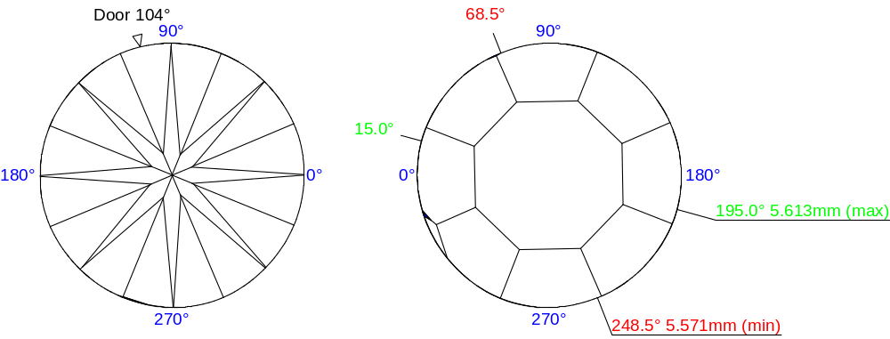
Invisible edges are drawn taking refraction into account | 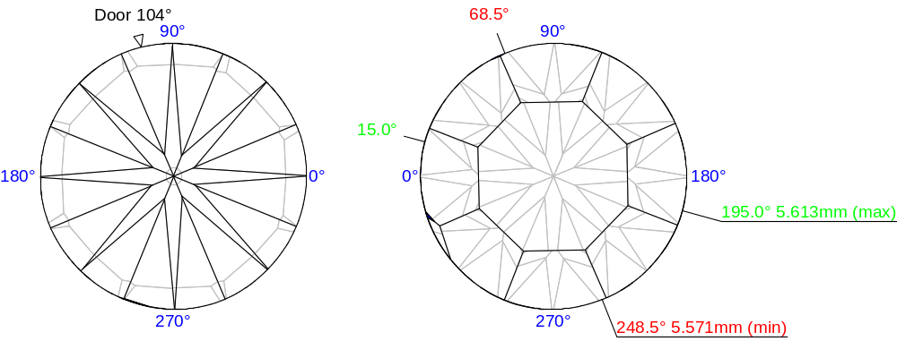

Plots
Girdle height plot | 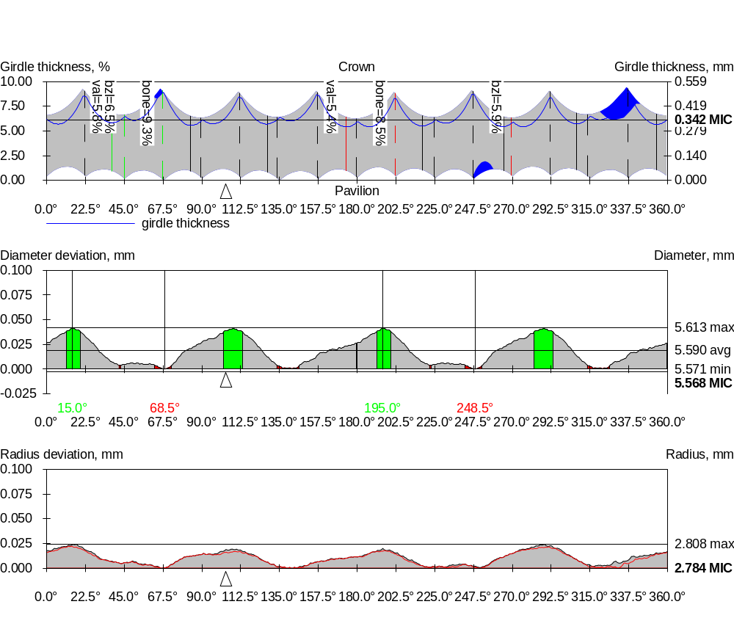

Diameter variation plot

Radius variation plot

Girdle asymmetry
Actual Length axis asymmetry | Length axis symmetry correction | Both axes symmetry correction
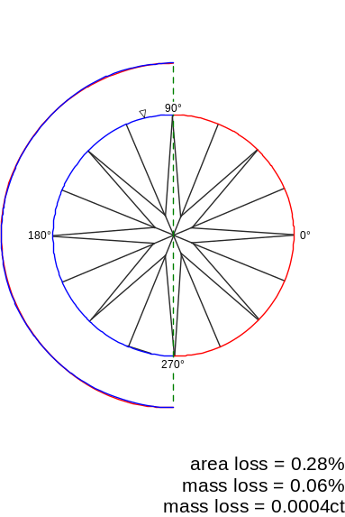 |  | 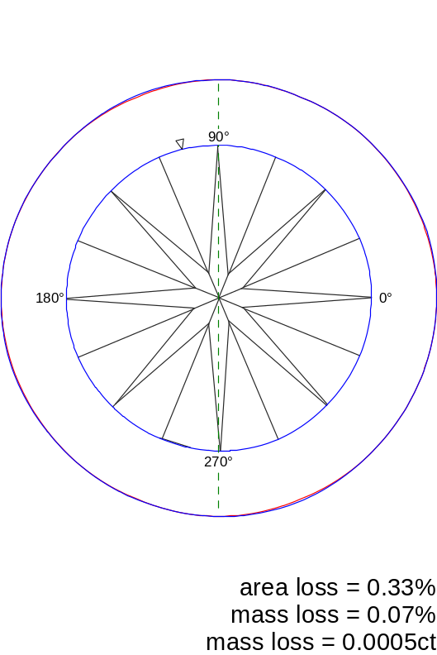  Both axes symmetry correction, area loss 0.33 %  Both axes symmetry correction, mass loss 0.07 %  Both axes symmetry correction, mass loss 0.0005 ct
Area loss 0.28 %  Mass loss 0.06 %  Mass loss 0.0004 ct | Area loss 0.28 %  Mass loss 0.06 %  Mass loss 0.0004 ct
Actual Width axis asymmetry | Width axis symmetry correction
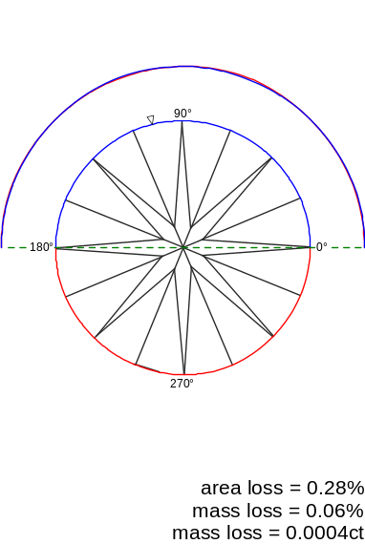
Area loss 0.28 %  Mass loss 0.06 %  Mass loss 0.0004 ct | Area loss 0.28 %  Mass loss 0.06 %  Mass loss 0.0004 ct

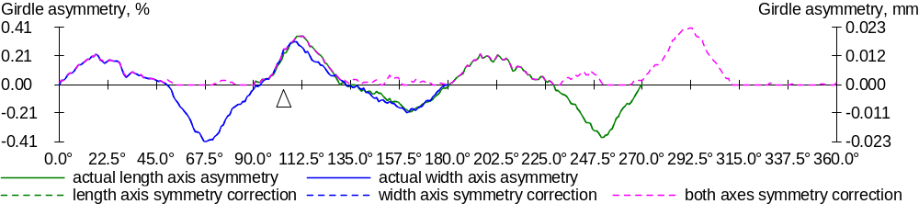

Facets slope and azimuth angles
 | 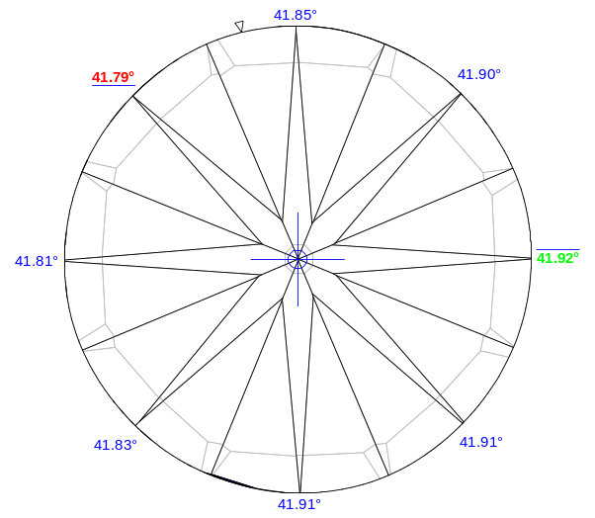 |  |  | 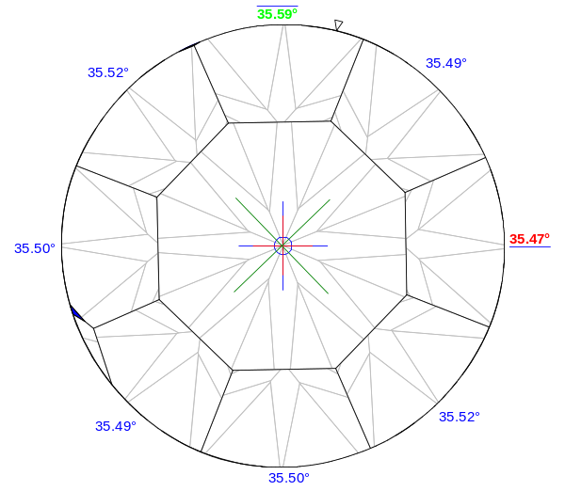
 | Pavilion main facets slope angles.  Invisible edges are drawn taking refraction into account |  |  | Crown main facets slope angles.  Invisible edges are drawn taking refraction into account
 | 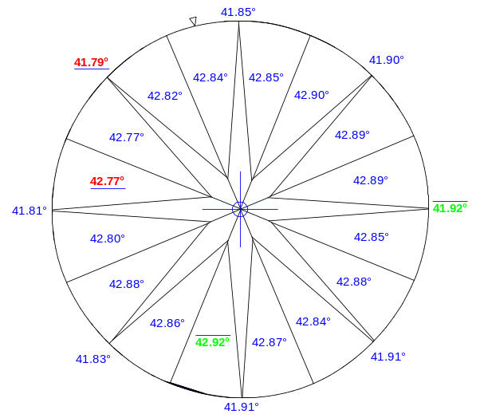 |  |  | 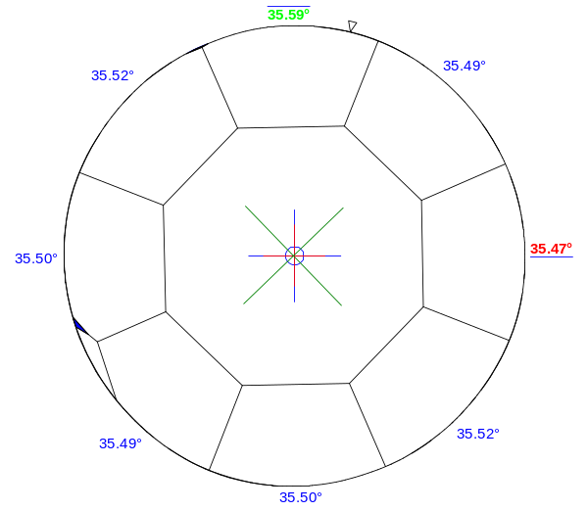
 | Pavilion main facets and lower girdle facets slope angles |  |  | Crown main facets, upper girdle facets, and star facets slope angles
 | 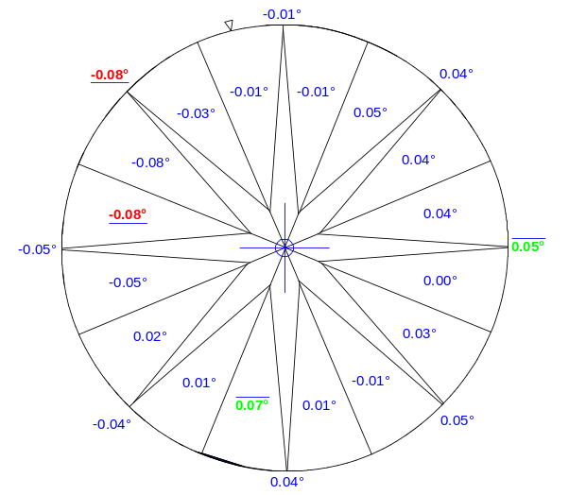 |  |  | 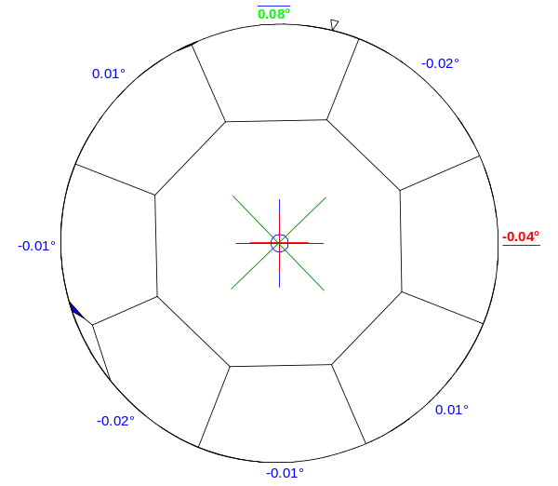
 | Deviation of pavilion main facets and lower girdle facets slope angles from the average values |  |  | Deviation of pavilion main facets and lower girdle facets slope angles from the average values

 | 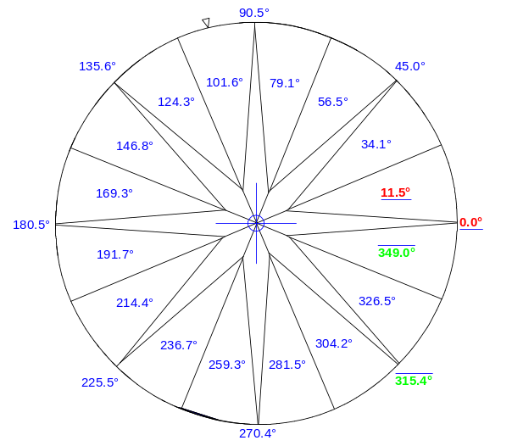 |  |  | 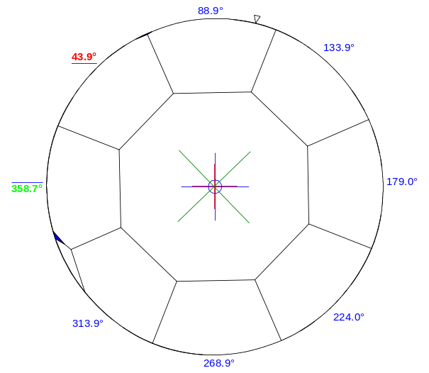
 | Pavilion main facets and lower girdle facets azimuth angles |  |  | Crown main facets, upper girdle facets, and star facets azimuth angles
 | 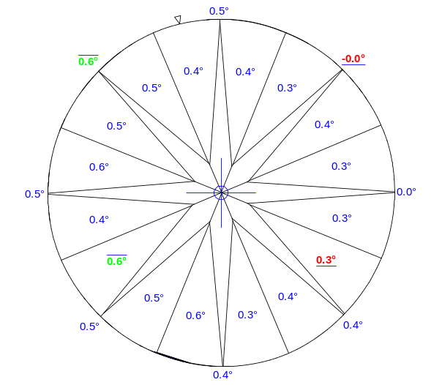 |  |  | 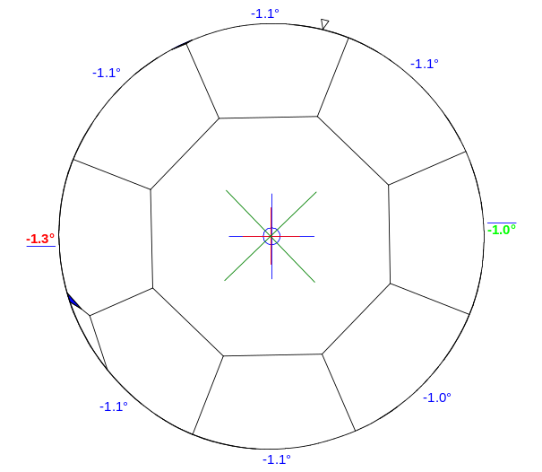
 | Deviation of pavilion main facets and lower girdle facets azimuth angles from their ideal positions for the round brilliant |  |  | Deviation of crown main facets, upper girdle facets, and star facets azimuth angles from their ideal positions for the round brilliant

Pavilion and crown heights
 | 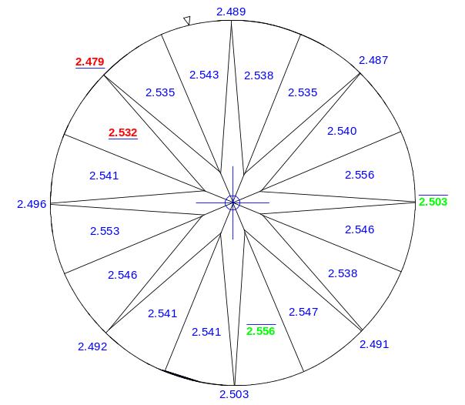 |  |  | 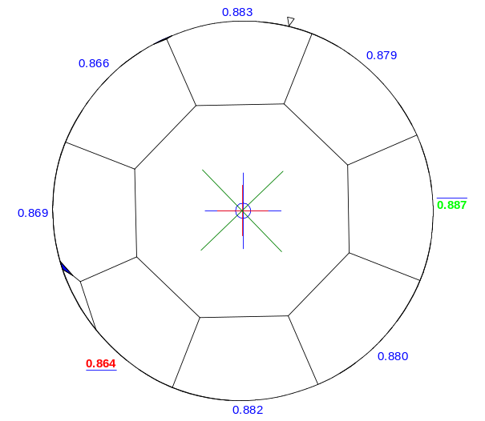
 | Pavilion heights bezel (outside) and  Pavilion heights valley type 2 (inside), mm |  |  | Crown heights (outside) and  Crown heights valley (inside), mm
 | 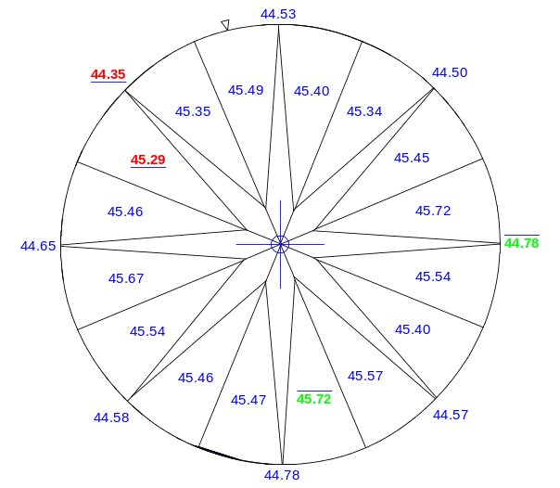 |  |  | 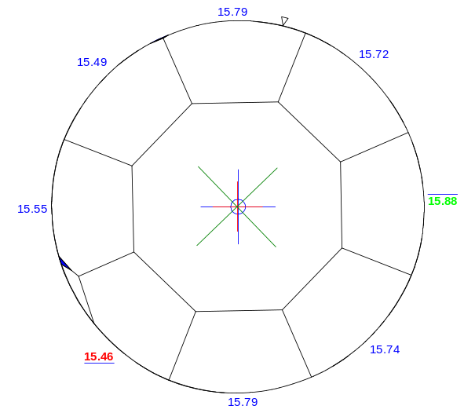
 | Pavilion heights bezel (outside) and  Pavilion heights valley type 2 (inside), % |  |  | Crown heights (outside) and  Crown heights valley (inside), %

 | 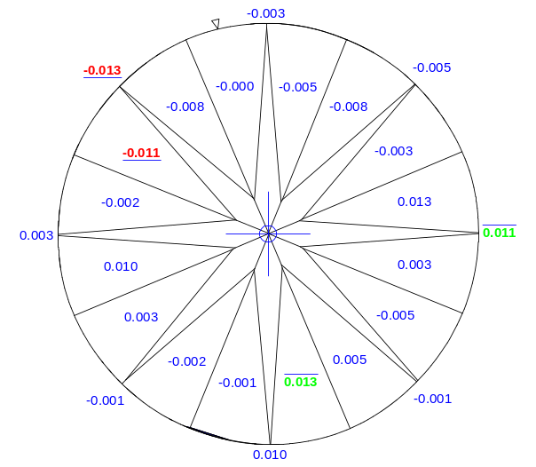 |  |  | 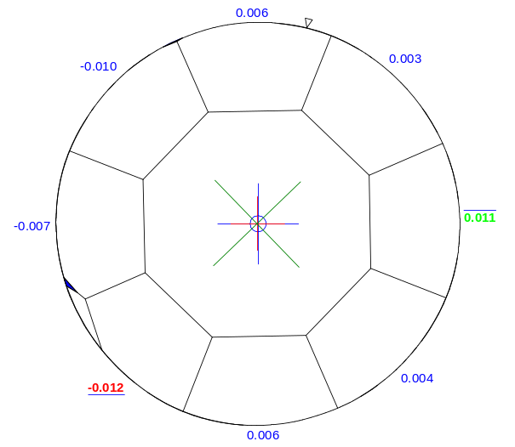
 | Deviations of Pavilion heights bezel (outside) and Pavilion heights valley type 2 (inside) from the average values, mm |  |  | Deviations of Crown heights (outside) and Crown heights valley (inside) from the average values (mm)
 | 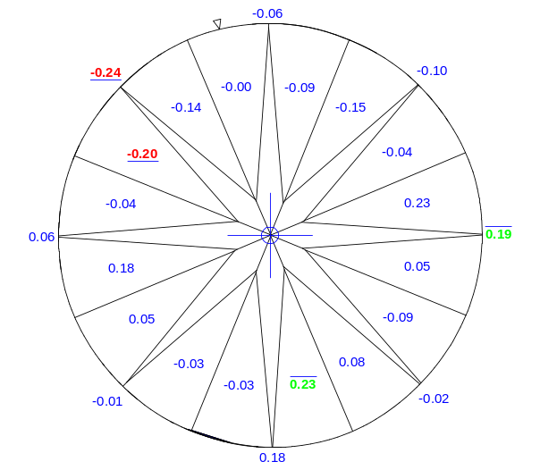 |  |  | 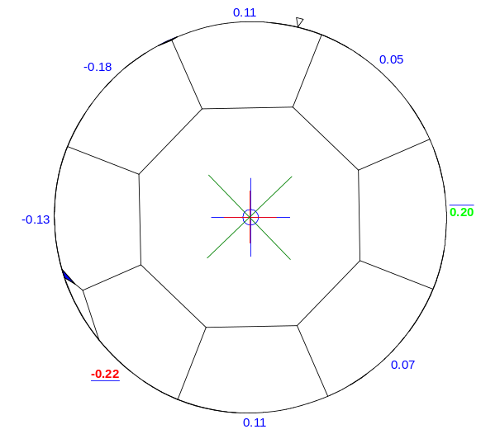
 | Deviations of Pavilion heights bezel (outside) and Pavilion heights valley type 2 (inside) from the average values (%) |  |  | Deviations of Crown heights (outside) and Crown heights valley (inside) from the average values (%)

Girdle facets slope and azimuth angles
 | 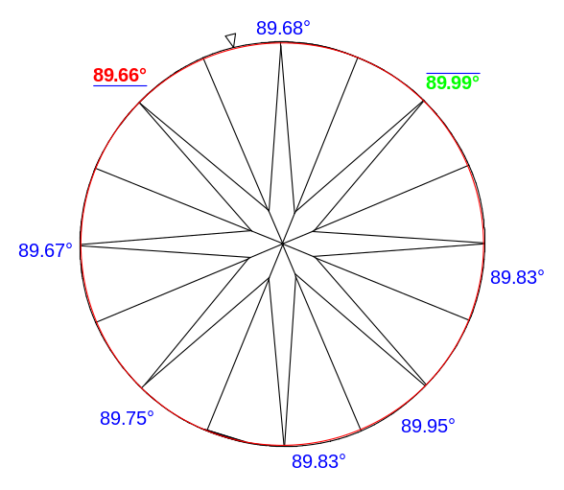 |  |  | 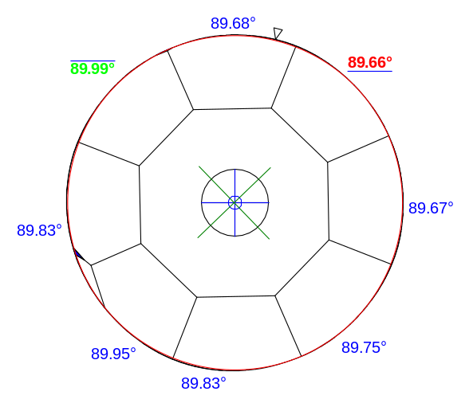
Girdle facets slope angles
 | 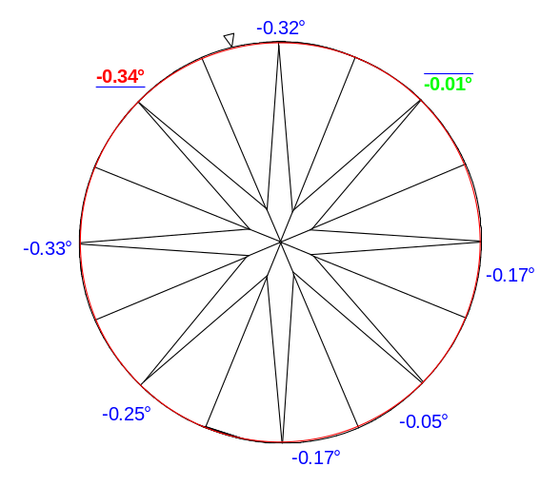 |  |  | 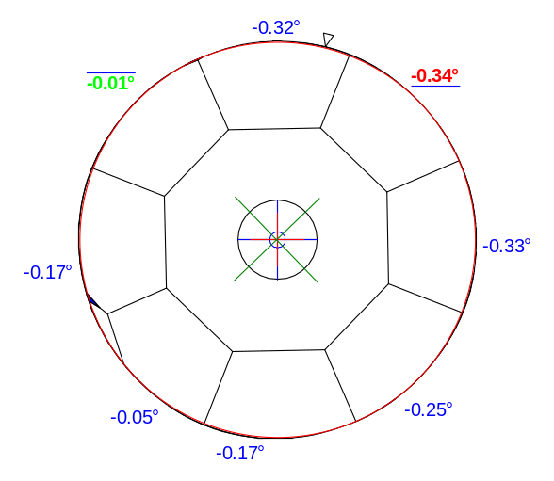
Deviation of girdle facets slope angles from there ideal (90°)

 | 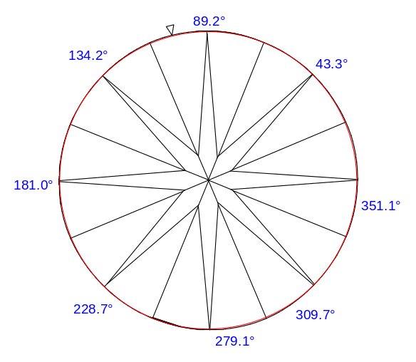 |  |  | 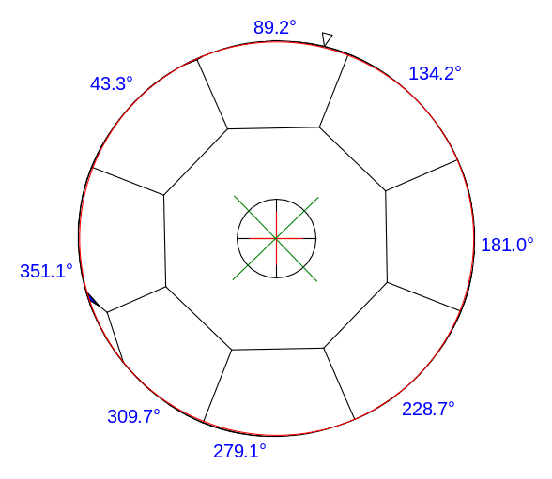
Girdle facets azimuth angles
 | 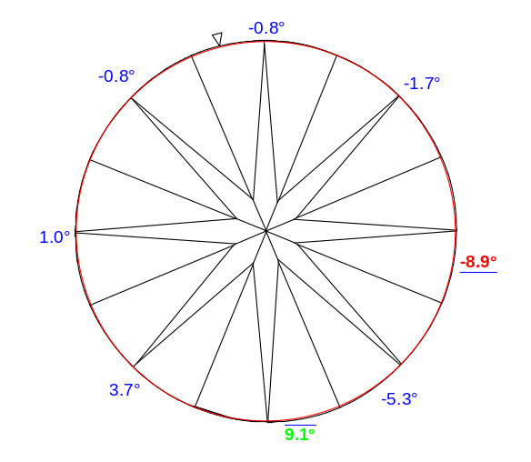 |  |  | 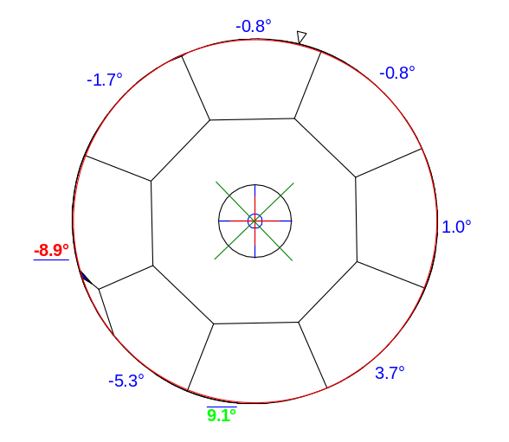
Deviation of girdle facets azimuth angles

All facets slope and azimuth angles without breakdown into groups
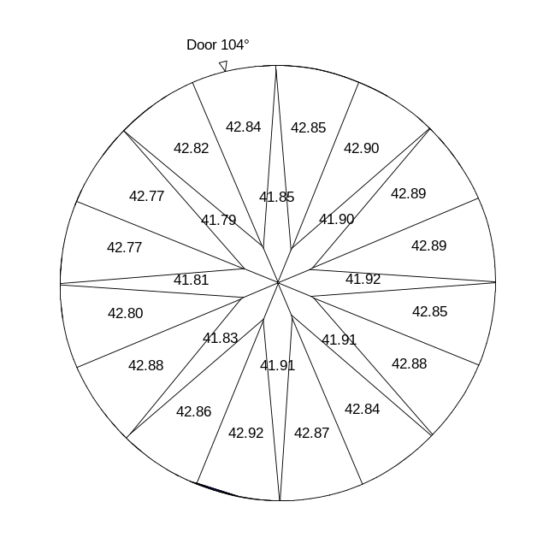 | 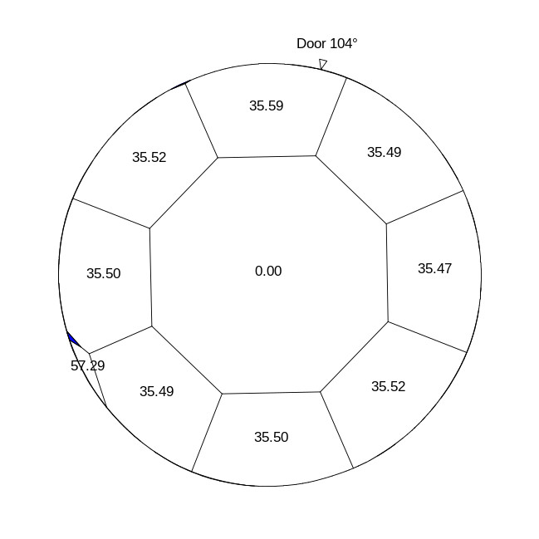
All facets slope angles without breakdown into groups
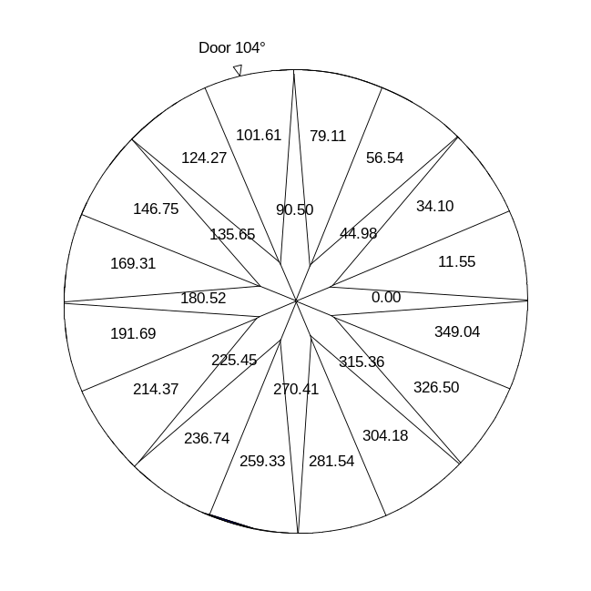 | 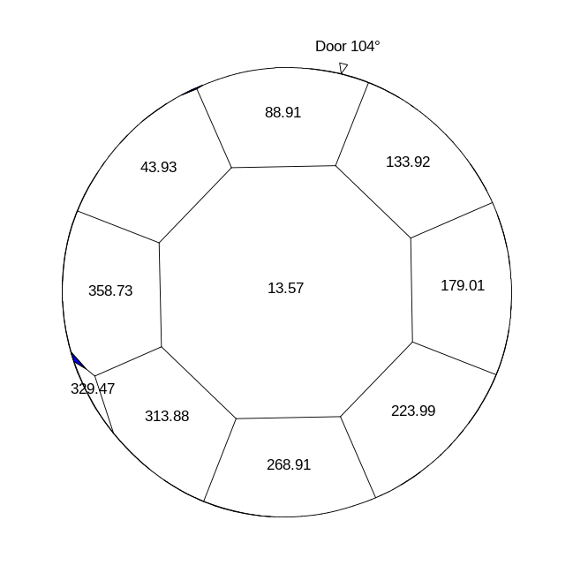
All facets azimuth angles without breakdown into groups

All facets heights without breakdown into groups
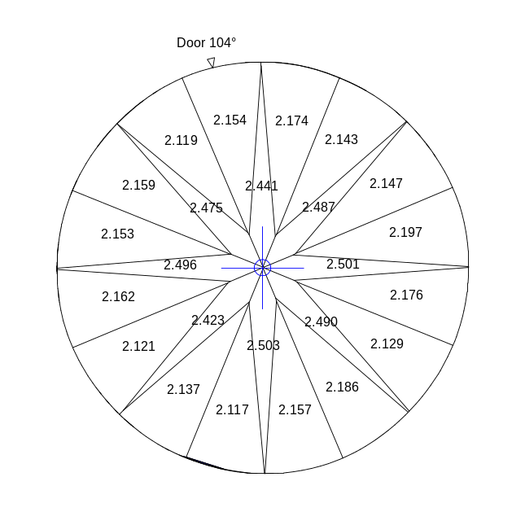 | 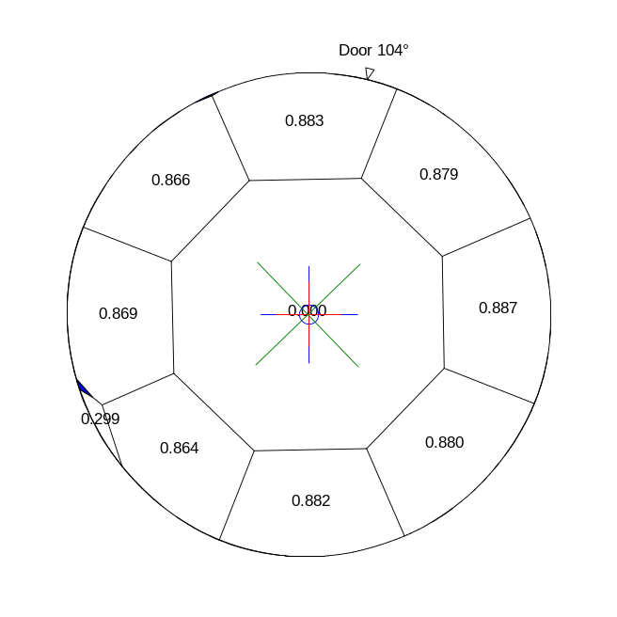
All facets heights without breakdown into groups (mm)
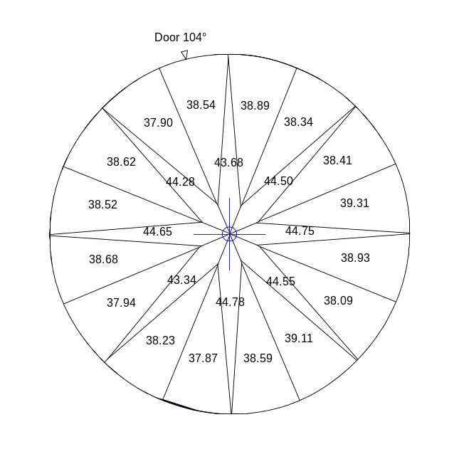 | 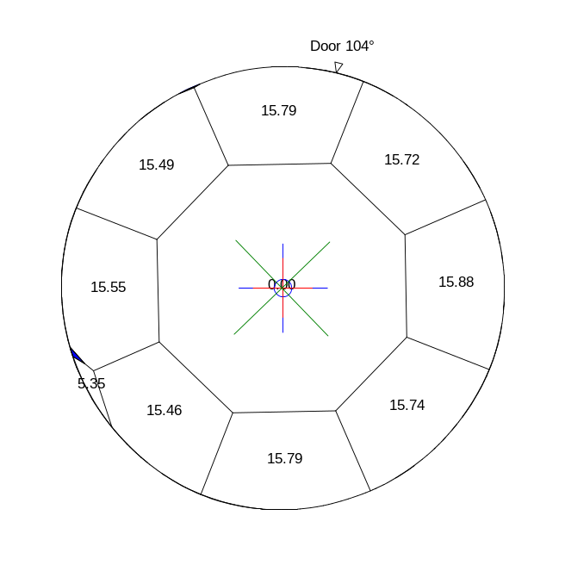
All facets heights without breakdown into groups (%)

Additional illustrations
 | 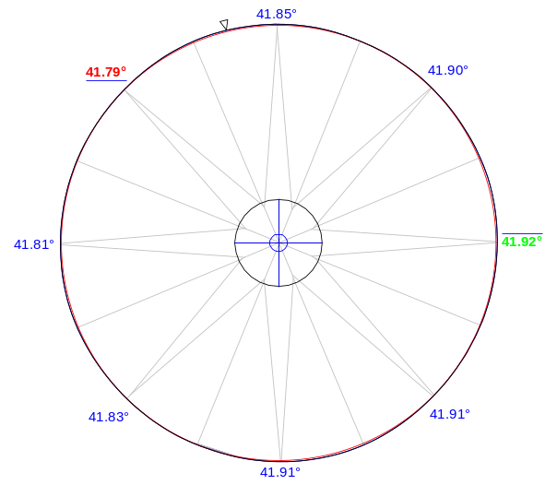 |  |  |  |  |  | 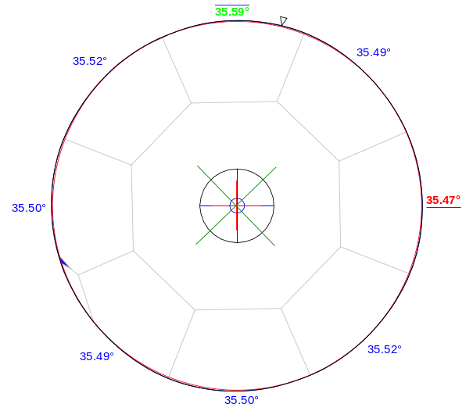
Pavilion and crown views with indication of the maximum circle
that may be inscribed (MIC) in the girdle outline along with the section of the model in the circle's plane,
and main facets slope angles
 |  | 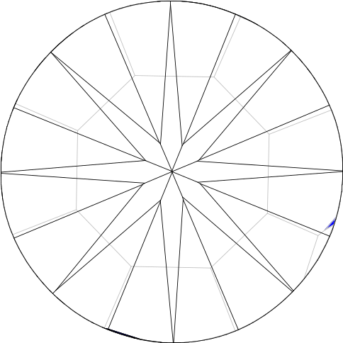 |  |  |  |  |  | 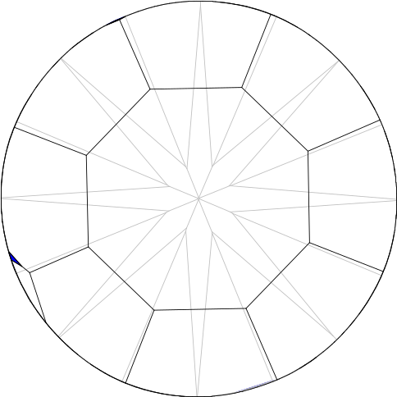
 |  | Pavilion and crown views with indication of invisible edges without refraction

 | Girdle center |  | Culet center |  | Тable center | 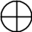 | MIC center

